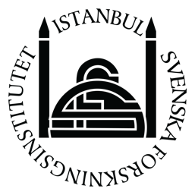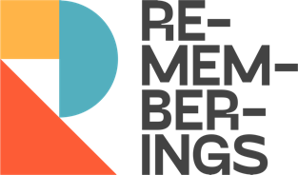

Call for Applications
Summer School
Remembering and Coexisting in Turkey and the Eastern Mediterranean

June 20 - July 1 2022
Swedish Research Institute in Istanbul

This summer school offers a unique opportunity for students and civil society activists to deepen their knowledge on pluralism, historical trauma and human rights in Turkey and the Eastern Mediterranean. The aim is to engage in conceptual discussions, advance methodological skills, and develop a network with leading scholars and civil society organizations active in these fields.
Participants and lecturers will discuss what cultural pluralism has meant in the past, what it means today, and survey how Turkey and other Eastern Mediterranean countries have struggled with their culturally pluralistic heritage and how these developments relate to the development of human rights. Special attention is given to oral history as a methodology and to the dynamics between academia and civil society in the advancement of knowledge related to these themes in the public sphere.
This summer school is organized for the second time by the Swedish Research Institute in Istanbul (SRII), financially supported by the Swedish Institute (SI), and held in collaboration with civil society organizations in Turkey.
The 10-day long full-time program will include seminars, workshops, study visits, and other interactive activities. Opportunities for one-on-one mentorship around individual research topics will also be provided.
Accommodation and travel expenses will be fully covered for participants living outside of Istanbul.

Who can apply
Undergraduate and graduate students, as well as civil society activists working on history, sociology, cultural heritage, cultural pluralism, memory studies, human rights, and other related fields. Fluency in both English and Turkish is required. Applications from students with limited access to international higher education programmes and who seek to further their work in these fields are strongly encouraged.

How to apply
Please send your CV and a letter of motivation that includes a brief research proposal to sriiapplication@gmail.com by March 31.
Participants will be notified by the end of April.
We look forward to receiving your application!

Important note: Due to the Covid-19 pandemic, participants are required to present their vaccination cards.

